1. Make this not a link. Should look just like the version number and agent name.

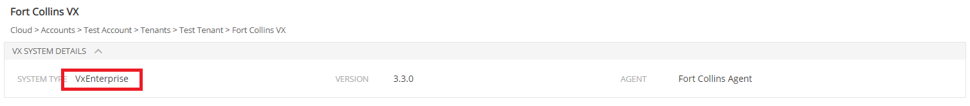

1. Turns out they want the system version to be “3.3.0”, because 3.7 sounds too far away. Sorry, my bad. Here are the 4 places to change it:

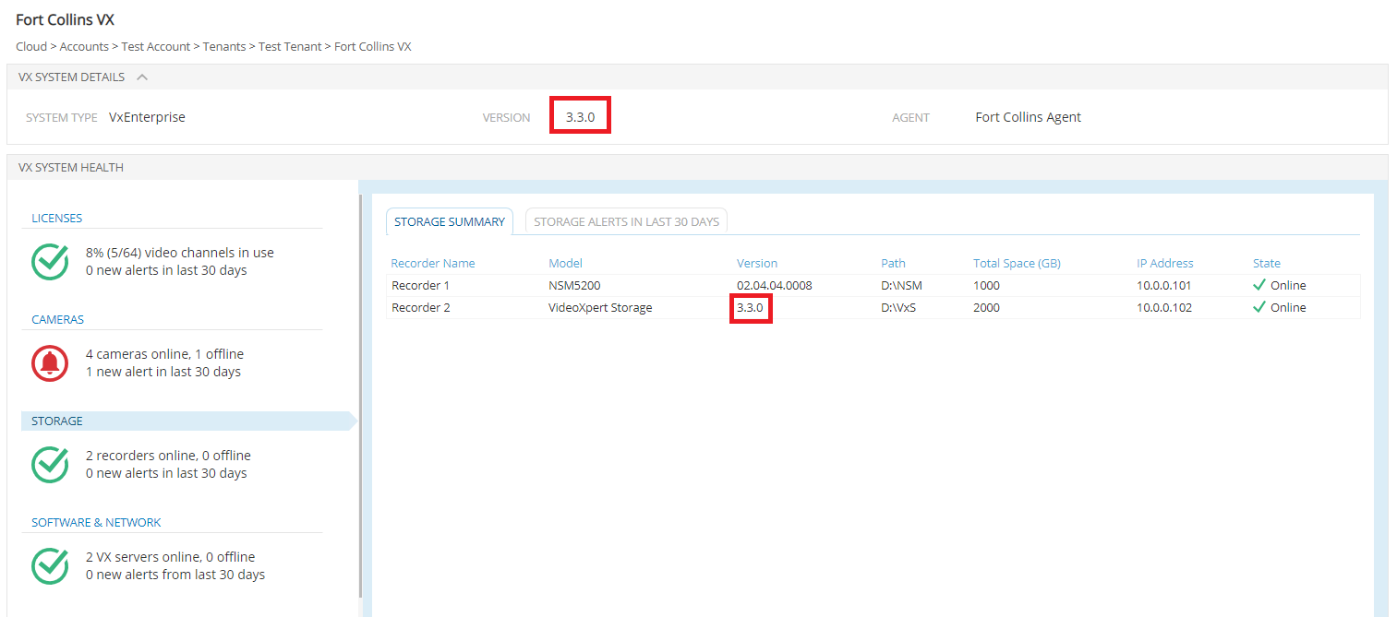

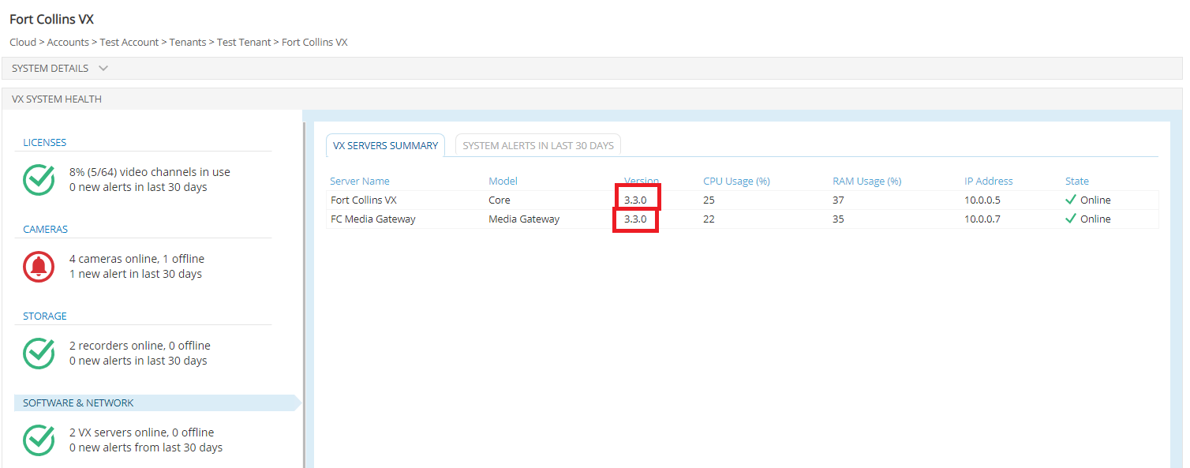

1. Change this text to say “SUP Active”:

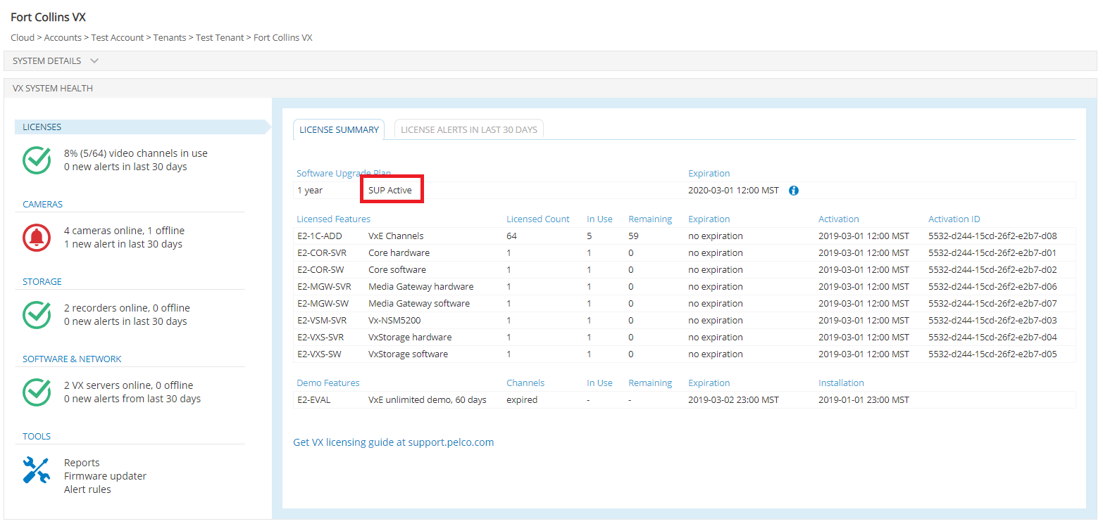

1. Fix a typo I had in the SUP Expiration Info Modal. (I had misspelled “invalid”.)

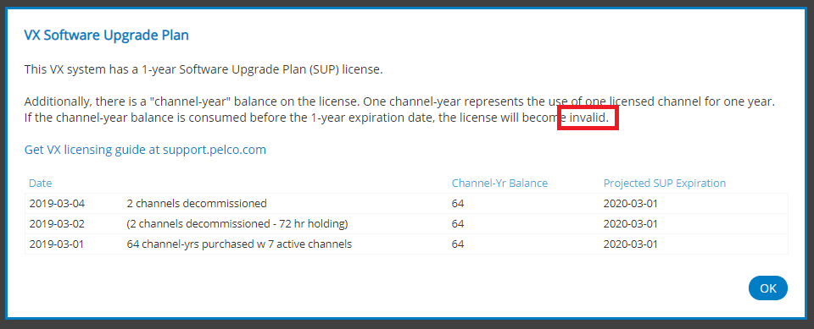

1. Changes to firmware updater view.

5a. Remove text about “Firmware updates are available only for supported models of Pelco cameras” and line breaks from the top.

5b. Make Current Version of Camera 3 be “2.2.3.0”. So that only Camera 4 looks like it can be updated.

5c. Add something in the Last Update for Camera 4. Because the empty cell looks distracting and they want the focus to be on the Available Update part.

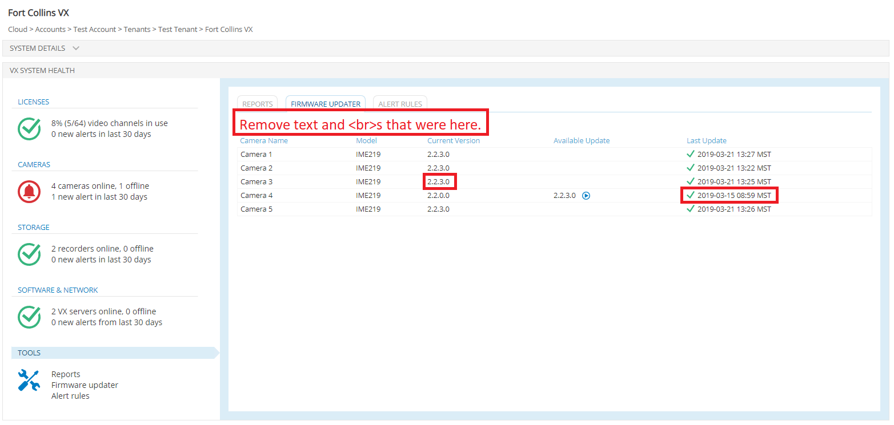

1. On Tools > Reports, for some reason, downloading the Storage Report doesn’t work. Super minor, what are the chances anyone will actually try this? 😊 But Camera Report and Quick Logs seem to download as expected. 